Business CareWare


How To Install and Setup CABS AutoEmail on Client Site
How To Document

Document Changes

Date | Version | Change Description | Changed By
06/12/2016 | 1.0 | Original Version | TT
18/01/2017 | 1.1 | Minor updates | TT
19/01/2017 | 1.2 | Minor Updates | TT
25/01/2017 | 1.3 | Minor Updates | TT

Table of Contents
1 Introduction 3
2 Installation/Update of CABS AutoEmail 3
3 CABS AutoEmail Configuration 6
3.1 Initial Configuration 6
3.2 Set Up Room Locations as Extras 9
3.3 Email Address Changes for the Test Environment 11
4 CABS AutoEmail Testing 12
4.1 Section CABS_AUTO_EMAIL_FUNCS_Trigger 12
4.2 Section CABS_AUTO_EMAIL_FUNCS 13
4.3 AutoEmail Template Sections 14
4.4 DeptEmailAddresses Section 15
4.5 SQL Agent Scheduled Jobs 16

Introduction

This document provides a description of how to install and/or update CABS AutoEmail as well as how to configure it. The document assumes MS SQL Database Mail is already configured.

Installation/Update of CABS AutoEmail

- All SQL scripts should be uncompressed and copied to an installation directory that MS SQL Server Management Studio has access to.

- In MS SQL Server Management Studio, open the script file called AutoEMail_Install.sql. Ensure the query window is connected to the target database. This script is responsible for installing or updating the AutoEmail components.

Before this script can be run it must be modified. This is clearly indicated near the top of the script as illustrated in the figure below:
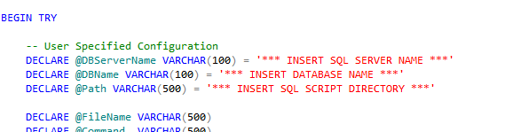
Figure 1 - Site specific Configuration

Replace the ‘*** INSERT …. ***’ strings with the appropriate data as illustrated in the Figure below:
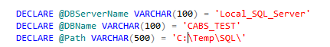
Figure 2 - Example User Specified Configuration

Ensure that the @Path variable ends with a backslash (\) character.

- Other scripts which create scheduled SQL jobs must be also be edited before they are run:

  - 18. Auto-Emailer Session Check.sql

Replace the text <<Put YOUR DB Name in Here>> and <<PUT THE LOGIN to run the job HERE>> with the appropriate details

  - 19. Auto-Emailer Recurring Emails Check.sql – Edit as described earlier.

  - 20. Auto-Emailer AEF_LINK Delete.sql - Edit as described earlier.
If these scripts are not required to be executed (for an update for example then they can be commented out.

- The install script uses xp_cmdshell which is not always enabled on a SQL Server.

  - Check if xp_cmdshell is enabled by running the following SQL:

SELECT CONVERT(INT, ISNULL(value, value_in_use)) AS config_value
FROM sys.configurations
WHERE name = 'xp_cmdshell' or name = 'show advanced options'

If the result is as below:

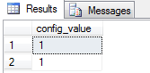
Figure 3 - xp_cmdshell Enabled

The installation script can be run.

If not run the following SQL:

EXEC sp_configure 'show advanced options', 1
GO
RECONFIGURE
GO

EXEC sp_configure 'xp_cmdshell', 1
GO
RECONFIGURE
GO

  - Execute the AutoEmail_Install SQL script.

  - The Messages Tab will display progress information and whether or not the script ran successfully:

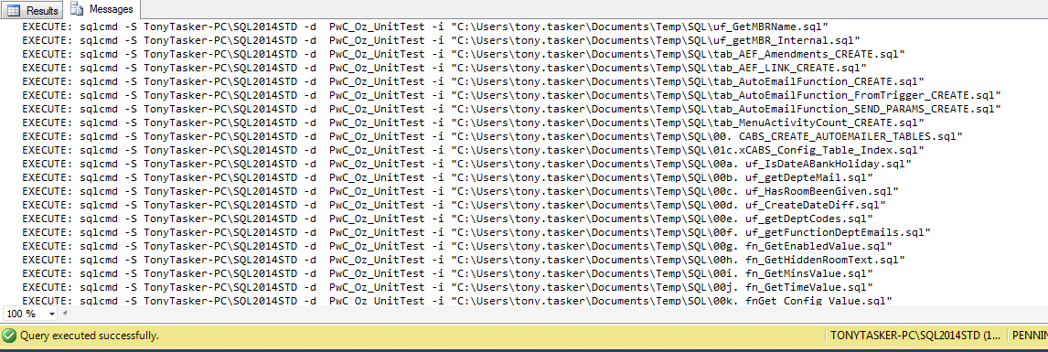
Figure 4 - AutoEmail Installation Messages

  - The Result Tab will display diagnostic information and should be checked carefully to ensure that there no errors or issues (such as dependency problems):

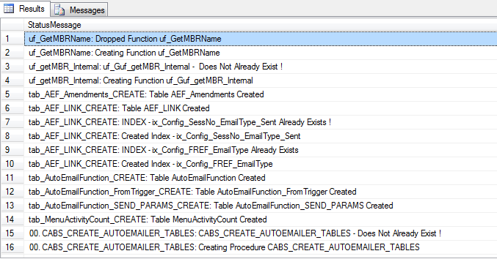
Figure 5 - AutoEmail Installation Status Messages

Issues will normally be indicated on a line that starts with “msg….”

  - If the sp_configure commands were previously run then reset the values.

Run the following SQL:

EXEC sp_configure 'xp_cmdshell', 0
GO
RECONFIGURE
GO

EXEC sp_configure 'show advanced options', 0
GO
RECONFIGURE
GO

  - Check if xp_cmdshell is disabled again by running the following SQL:

SELECT CONVERT(INT, ISNULL(value, value_in_use)) AS config_value
FROM sys.configurations
WHERE name = 'xp_cmdshell' or name = 'show advanced options'

If the result is as below:

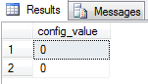
Figure 6 – xp_cmd_shell Disabled

CABS AutoEmail Configuration

Initial Configuration

Once all the files have been installed there should be a script that adds Autoemail configuration data to the database. The name will be of the format of “COMPANY NAME Configuration.sql” with “COMPANY NAME” being replaced with client name.

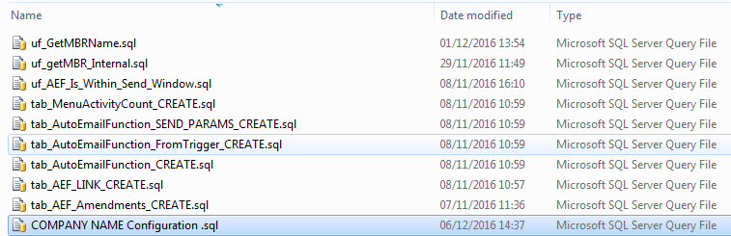
Figure 7 - Company Specific AutoEmail Configuration Script

This data will/could include Autoemail template definition data, Autoemail configuration data and any other Autoemail specific SQL. CABS Autoemail should initially be configured as disabled. If an update is being implemented then a decision will need to be made as to whether or not to disable autoemail functionality. This can be achieved by disabling the following SQL Jobs:

- Auto-Emailer Session Check and

- Auto-Emailer Recurring Emails Check

Open the script file in MS SQL Server Management Studio, ensure that the connection is with the appropriate database and execute the script.

To check that the script has worked correctly use the CABS Console. In Descriptions and Codes which can be found off the CABS Maintenance Menu or the System Menu as illustrated below,

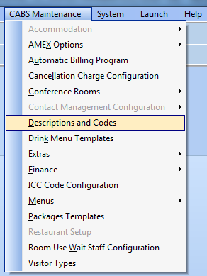
Figure 8 - Descriptions and Codes Menu Option (from CABS Maintenance Menu)

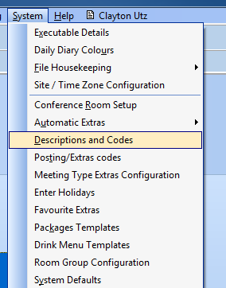
Figure 9 - Descriptions and Codes Menu Option (from System Menu)

Ensure that an AutoEmail Template section exists and is displayed in the Description and Codes window:

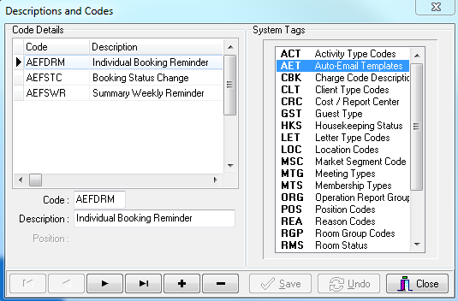
Figure 10 - AutoEmail Section in Descriptions and Codes

The templates displayed are site specific and Figure 10 may not be representative of every client site’s configuration.

Next, in System Defaults,

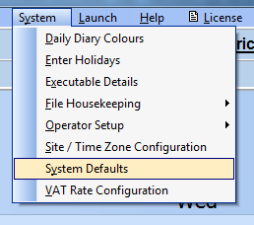
Figure 11 - System Defaults Menu Option

Ensure that the relevant sections have been added with the appropriate data – Note that the drop down menu at the bottom right of the window should be set to “SQL Config Settings”:

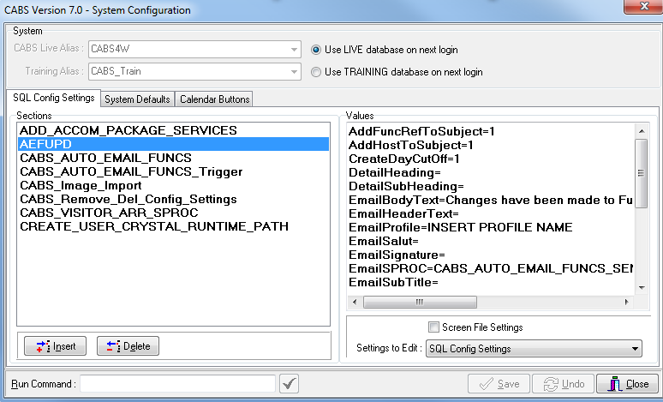
Figure 12 - AutoEMail Configuration

Finally run Query

SELECT * FROM vw_AEFLink

This query displays all autoemails that are queued. The figure below shows records for 3 system generated autoemails but no businesss triggered autoemails.

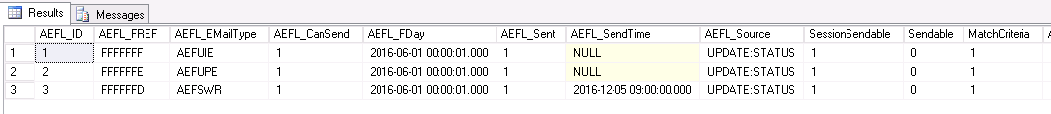
Figure 13 - Records Inserted Into vw_AEFLink

Set Up Room Locations as Extras

Under certain circumstances Autoemails will use email addresses that are assigned to Extras that are specifically related to Locations. In this scenario there is a configuration script which needs to be run called AddLocationsAsExtras.sql.

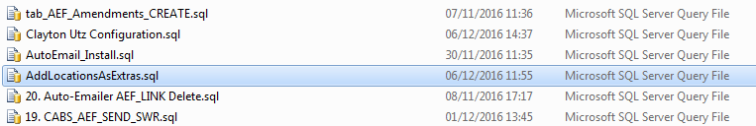
Figure 14 – The AddLocations_Install.sql

Open this script in MS SQL Management Studio and run it. By default the email address configured on these Extras will be helpdesk@bcluk.com. These Extras will need to be located and amended as appropriate. To do this click on the “Posting/Extras Codes” menu option:

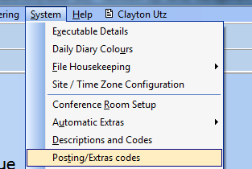
Figure 15 - Posting/Extras Codes Menu Option

The following Posting Code configuration window should be displayed.

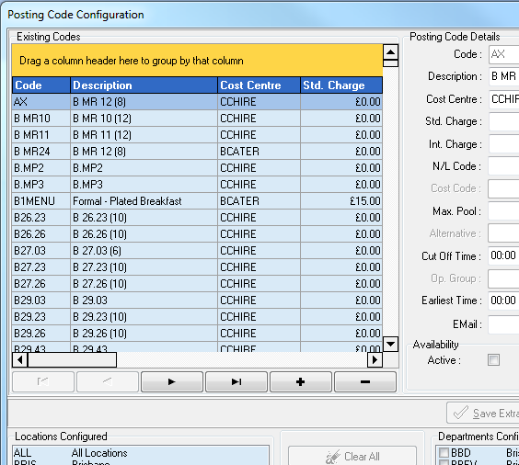
Figure 16 - Posting Code Configuration WIndow

Next click on the “Cost Centre” column header and drag it into the “Orange” section of the window. Then locate and expand the row “Cost Centre: CCHIRE” and highlight a row as illustrated below:

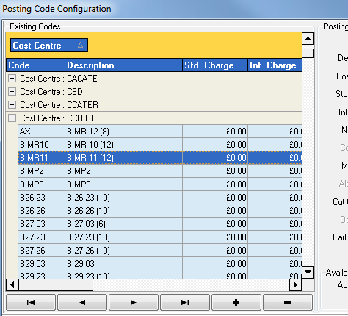
Figure 17 - Cost Centre CCHIRE Expanded

Finally sort by Description and scroll to the top of the page. A number of Extras with a description starting with “Additional Info – “ should be visible.

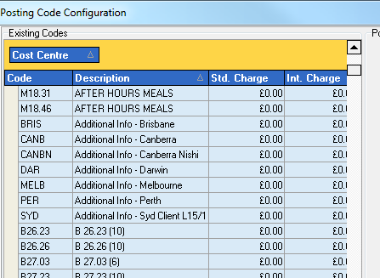
Figure 18 - Identifying Room Location Extras

Click on these Extras one by one and amend the email address as required. In testing the email address used may not be a live one.

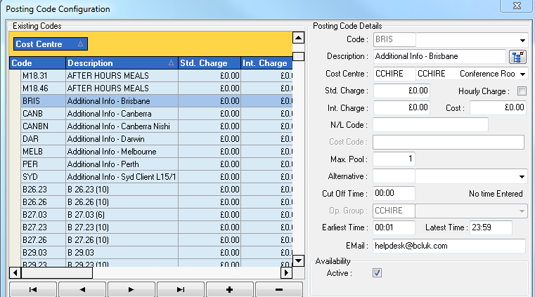
Figure 19 - Edit Room Location Extra Email Address

After each change click the “Save Extra” button.

Email Address Changes for the Test Environment

Often databases used for testing and development are copies of a production system and as such could contain live data. When testing CABS Autoemailer emails should not be sent to operational staff. To ensure that this potential issue is overcome any live email addresses should be replaced with test ones.

The following SQL queries will help to determine whether or not email changes have to be made on the test/development system:

SELECT * FROM OP_FILE WHERE O_EMAIL IS NOT NULL AND O_EMAIL <> ''

SELECT * FROM CONTACTS WHERE CT_EMAIL IS NOT NULL AND CT_EMAIL <> ''

SELECT * FROM MBRFILE WHERE MBR_EMAIL IS NOT NULL AND MBR_EMAIL <> ''

SELECT * FROM MBRFILE WHERE MBR_CEMAIL IS NOT NULL AND MBR_CEMAIL <> ''

If any emails need changing then run the following SQL can be run. Note – replace the string “*** INSERT EMAIL ADDRESS ***” with an appropriate email address.

UPDATE OP_FILE SET O_EMAIL = '*** INSERT EMAIL ADDRESS ***'
WHERE O_EMAIL IS NOT NULL AND O_EMAIL <> ''

Note: If the above query affects more than 1 record it may fail if the trigger OPERATOR_USER_LOG is enabled on table OP_FILE. In that instance, disable the trigger, run the query and then re-enable the trigger.

UPDATE CONTACTS SET CT_EMAIL = '*** INSERT EMAIL ADDRESS ***'
WHERE CT_EMAIL IS NOT NULL AND CT_EMAIL <> ''

UPDATE MBRFILE SET MBR_EMAIL = '*** INSERT EMAIL ADDRESS ***'
WHERE MBR_EMAIL IS NOT NULL AND MBR_EMAIL <> ''

UPDATE MBRFILE SET MBR_CEMAIL = '*** INSERT EMAIL ADDRESS ***'
WHERE MBR_CEMAIL IS NOT NULL AND MBR_CEMAIL <> ''

CABS AutoEmail Testing

At this point CABS Autoemail should be installed and configured but not enabled. There are a number of final tasks to complete before CABS Autoemails will run as illustrated in the following sections.

Section CABS_AUTO_EMAIL_FUNCS_Trigger

Navigate to the CABS_AUTO_EMAIL_FUNCS_Trigger in System Defaults as described in section 3.1:

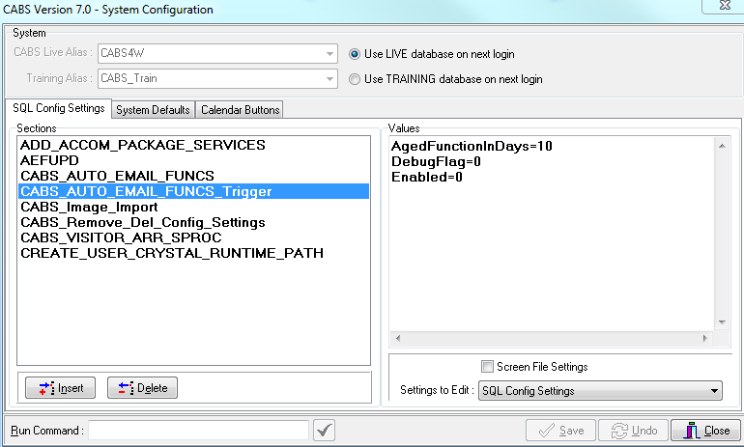
Figure 20 - CABS_AUTO_EMAIL_FUNCS_Trigger Configuration

Whilst testing change the value of the debug flag to 1 (otherwise ensure it is set to 0) and when ready to test set the Enabled flag to 1.

Section CABS_AUTO_EMAIL_FUNCS

In section CABS_AUTO_EMAIL_FUNCS a number of settings will need to be checked and amended:

- During testing set DebugFlag to a value of 1 (otherwise ensure it is set to 0)

- When ready to start testing set the Enabled flag to 1

- Check the following values to ensure settings are correct and amend accordingly:

  - Company

  - AdminEmailAddr

This email address is used by the Autoemail component as a catch all email address if for some reason a recipient email address cannot be determined.

  - CurrencySymbol

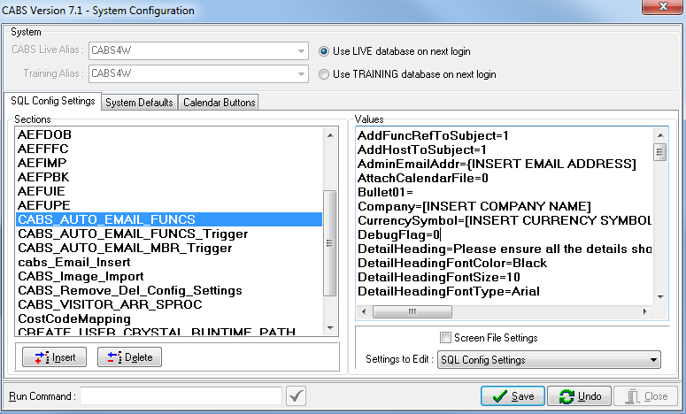
Figure 21 - CABS_AUTO_EMAIL_FUNCS Configuration

AutoEmail Template Sections

In each AutoEmail template section set the Email Profile to whatever has been configured in SQL Database Mail.

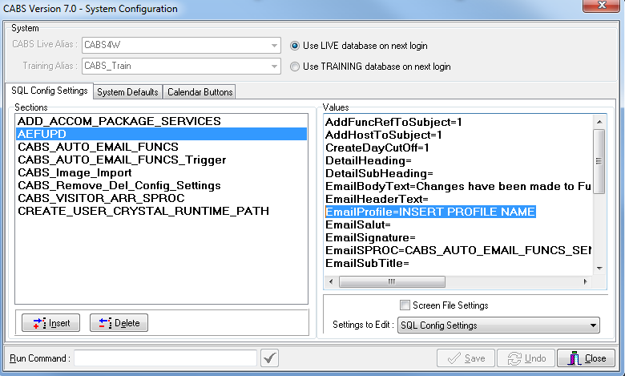
Figure 22 – Email Profile Configuration

For the EmailProfile switch replace the “INSERT PROFILE NAME” with the name of the profile previously setup.

Each template needs to be enabled.

There are 3 switches which can be amended for this which are initially set to off:

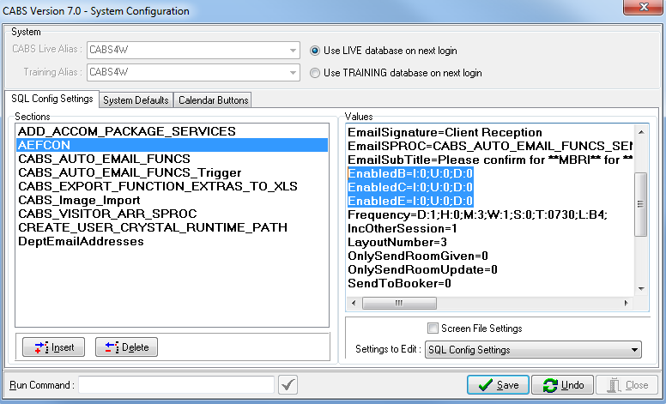
Figure 23 - Switches to Enable AutoEmail Template

The switches are used as follows:

- EnabledB is used to trigger an autoemail if the booking is new (I=1), amended (U=1) or deleted (D=1).

- EnabledC used to trigger an autoemail if a classification record is new (I=1), amended (U=1) or deleted (D=1).

- EnabledE used to trigger an autoemail if an extra is is new (I=1), amended (U=1) or deleted (D=1).

Previous versions of autoemail used a single switch called Enabled which had the same format. A single configuration switch called Enabled will still work but is deprecated.

DeptEmailAddresses Section

Review the section DeptEmailAddresses and insert any email addresses as required. The figure below is illustrative only as configuration will be client specific.

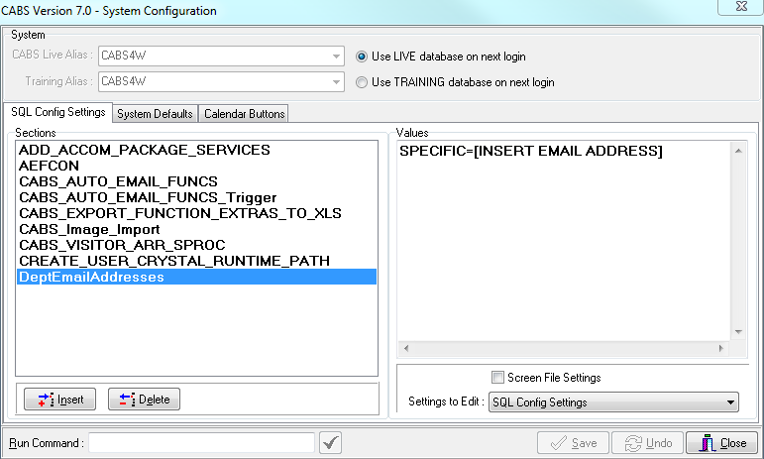
Figure 24 - DeptEmailAddresses Section

SQL Agent Scheduled Jobs

A number of scheduled jobs are installed as part of the CABS Autoemail installation process. The main job to enable is [CABS] Auto-Emailer Session Check.

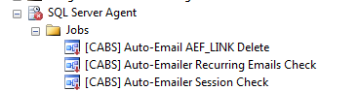
Figure 25 - AutoEmail Scheduled Jobs

This job polls regularly (every minute between 08:00 and 18:00 by default) and will attempt to deliver any Autoemails that are queued.

